EMAIL

STEP1 : without attachment on console

public class SendEmailExample {
public static void sendEmail() {

Messaging.SingleEmailMessage mail = new Messaging.SingleEmailMessage();

mail.setToAddresses(new String[] {'this-is-not-an-email'});
mail.setSubject('Test Email from Salesforce Apex');
mail.setPlainTextBody('Hello, this is a test email sent using Apex.');

Messaging.SendEmailResult[] results =
Messaging.sendEmail(new Messaging.SingleEmailMessage[] {mail}, false);

if(results[0].isSuccess()){
System.debug('Email Sent Successfully');
}
else{
System.debug('Email Failed: ' + results[0].getErrors()[0].getMessage());
}
}
}

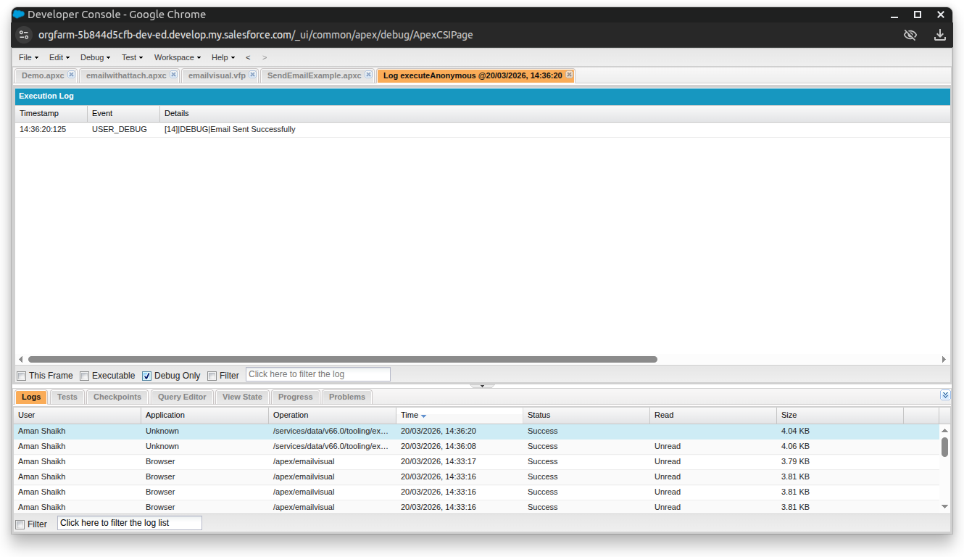

Now we will try for incorrect email without @ sign:

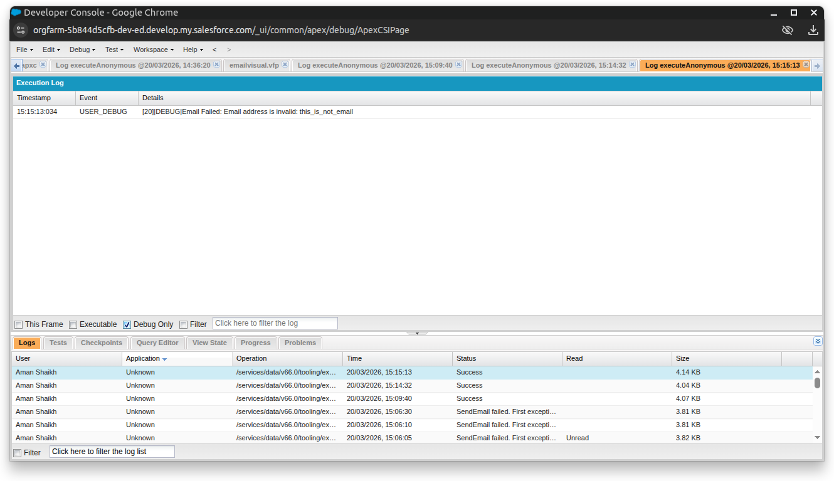

Now with attachment on command

public class WITH_ATTCH_ON_CONSOLE {
public static void sendEmail() {

Messaging.SingleEmailMessage mail = new Messaging.SingleEmailMessage();

mail.setToAddresses(new String[] {'mrrandom0775@gmail.com'});
mail.setSubject('Test Email with Attachment');
mail.setPlainTextBody('Please find the attached file.');

Messaging.EmailFileAttachment attach = new Messaging.EmailFileAttachment();
attach.setFileName('Attachment.txt');
attach.setBody(Blob.valueOf('This is the hardcoded file content.'));
attach.setContentType('text/plain'); // Correct method name

mail.setFileAttachments(new Messaging.EmailFileAttachment[] { attach });

Messaging.SendEmailResult[] results =
Messaging.sendEmail(new Messaging.SingleEmailMessage[] {mail}, false);

if(results[0].isSuccess()){
System.debug('Email Sent Successfully');
}
else{
System.debug('Email Failed: ' + results[0].getErrors()[0].getMessage());
}
}
}

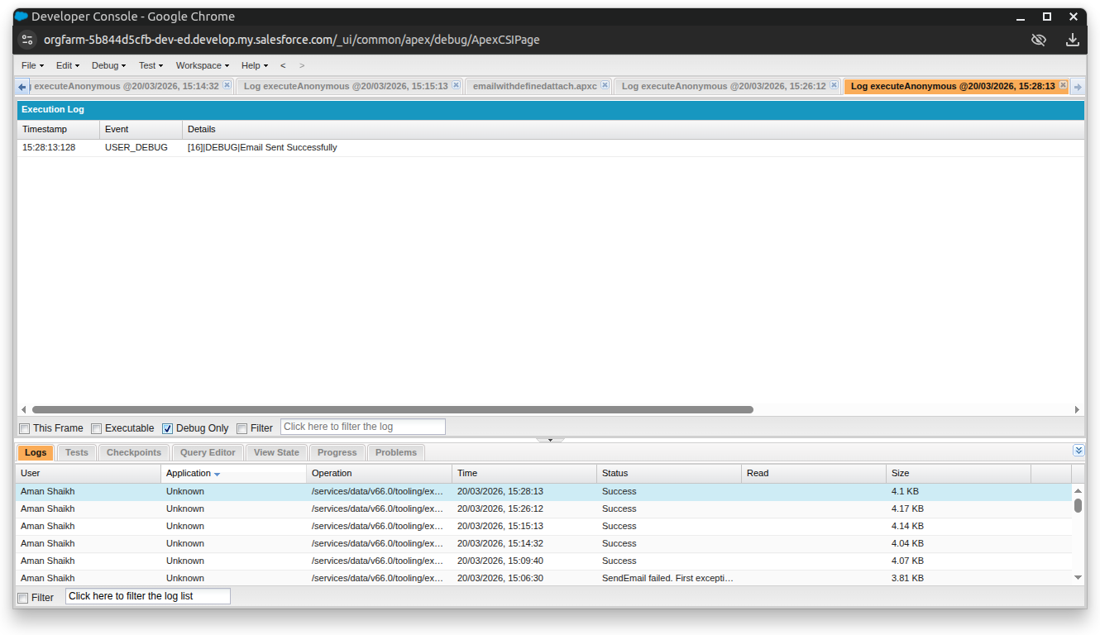

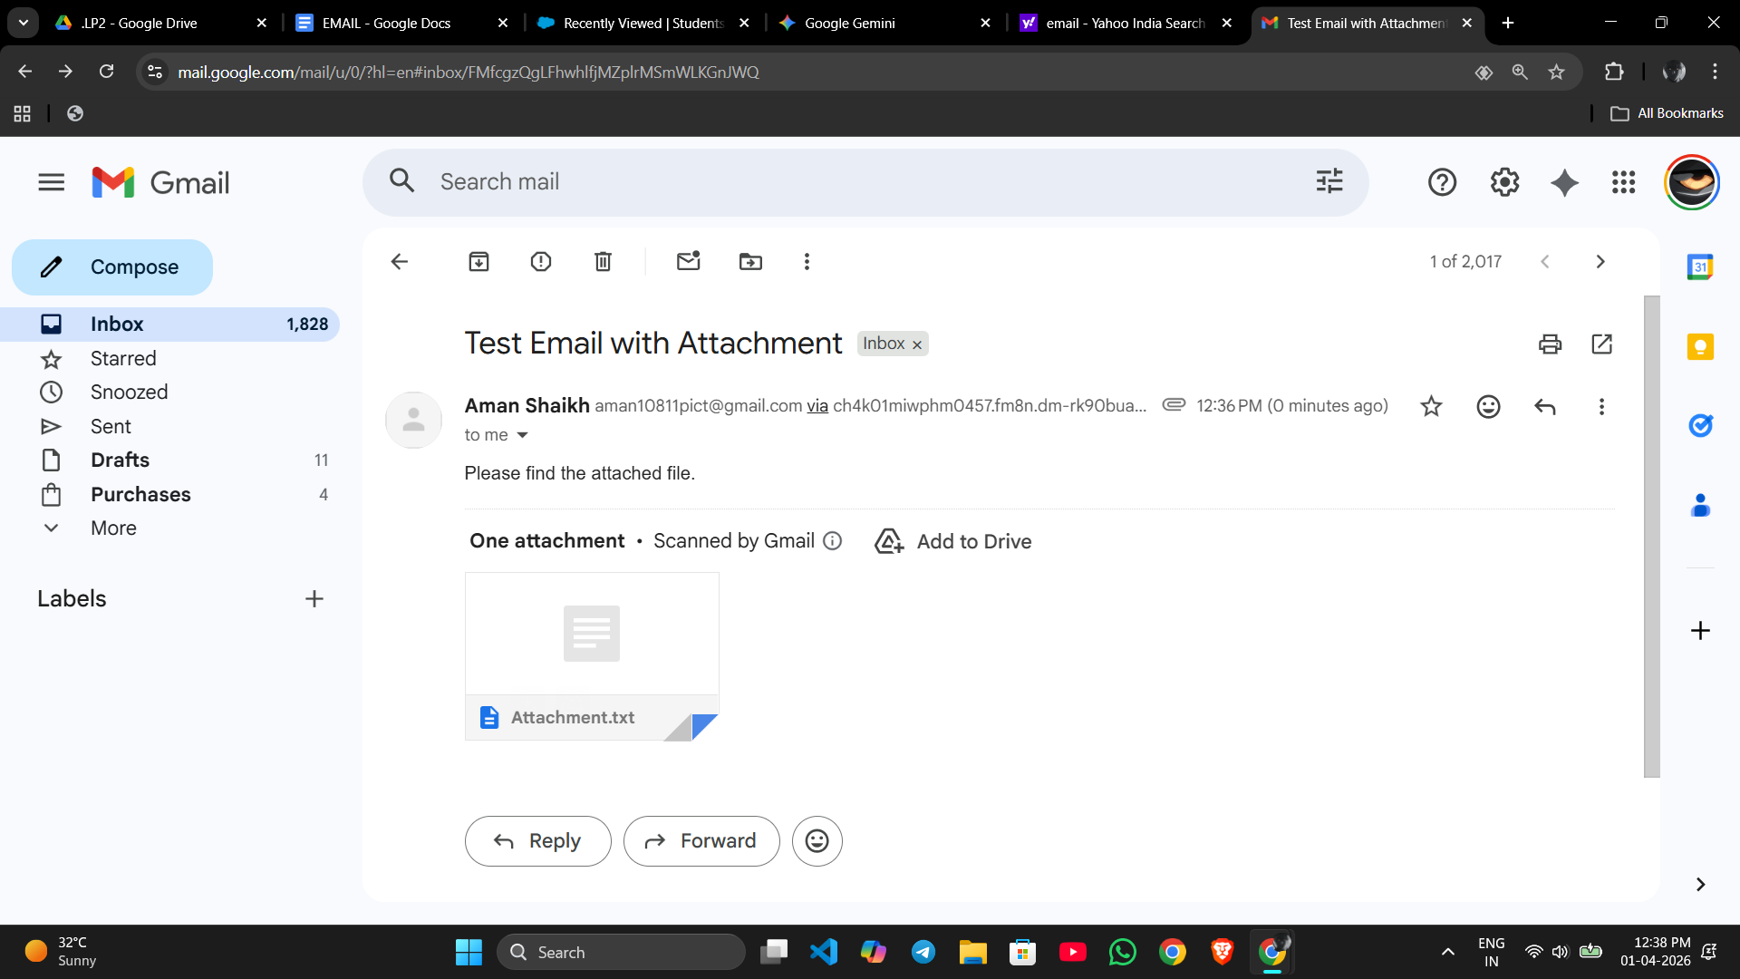

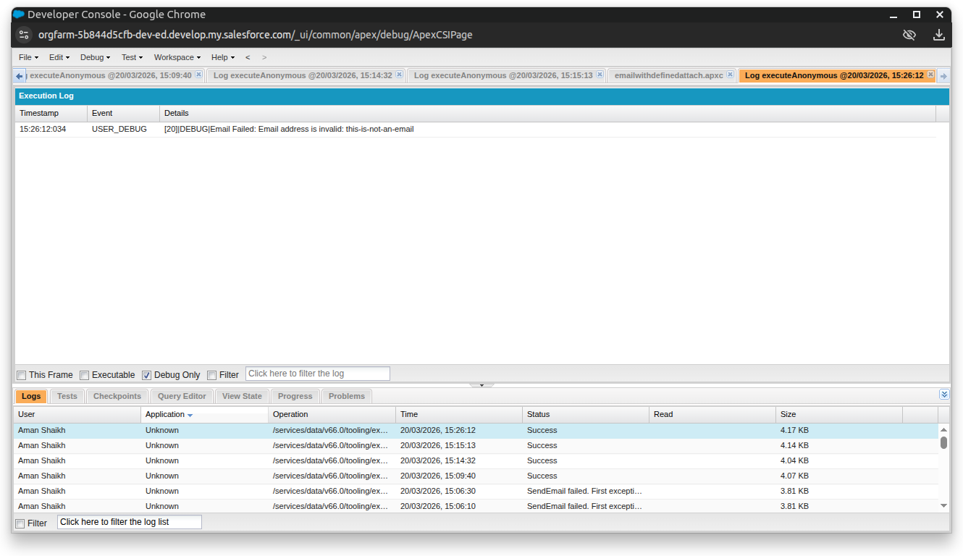

Now without attachment using visual force
Apex class
public class emailwithoutattach {
public String toAddress { get; set; }
public String emailSubject { get; set; }
public String emailBody { get; set; }

public void sendEmail() {
try {
Messaging.SingleEmailMessage mail = new Messaging.SingleEmailMessage();
mail.setToAddresses(new String[] { toAddress });
mail.setSubject(emailSubject);
mail.setPlainTextBody(emailBody);

Messaging.SendEmailResult[] results = Messaging.sendEmail(new Messaging.SingleEmailMessage[] {mail});

if(results[0].isSuccess()){
ApexPages.addMessage(new ApexPages.Message(ApexPages.Severity.CONFIRM, 'Email Sent Successfully'));
} else {
ApexPages.addMessage(new ApexPages.Message(ApexPages.Severity.ERROR, 'Email Failed: ' + results[0].getErrors()[0].getMessage()));
}
} catch (Exception e) {
ApexPages.addMessage(new ApexPages.Message(ApexPages.Severity.ERROR, 'Error: ' + e.getMessage()));
}
}
}

Visual force page
<apex:page controller="emailwithoutattach">
<apex:form>
<apex:pageMessages />
<apex:pageBlock title="Send Plain Email">
<apex:pageBlockSection columns="1">
<apex:inputText value="{!toAddress}" label="To Address" />
<apex:inputText value="{!emailSubject}" label="Subject" />
<apex:inputTextarea value="{!emailBody}" label="Body" rows="5" cols="50" />
</apex:pageBlockSection>

<apex:pageBlockButtons location="bottom">
<apex:commandButton value="Send Email" action="{!sendEmail}" />
</apex:pageBlockButtons>
</apex:pageBlock>
</apex:form>
</apex:page>

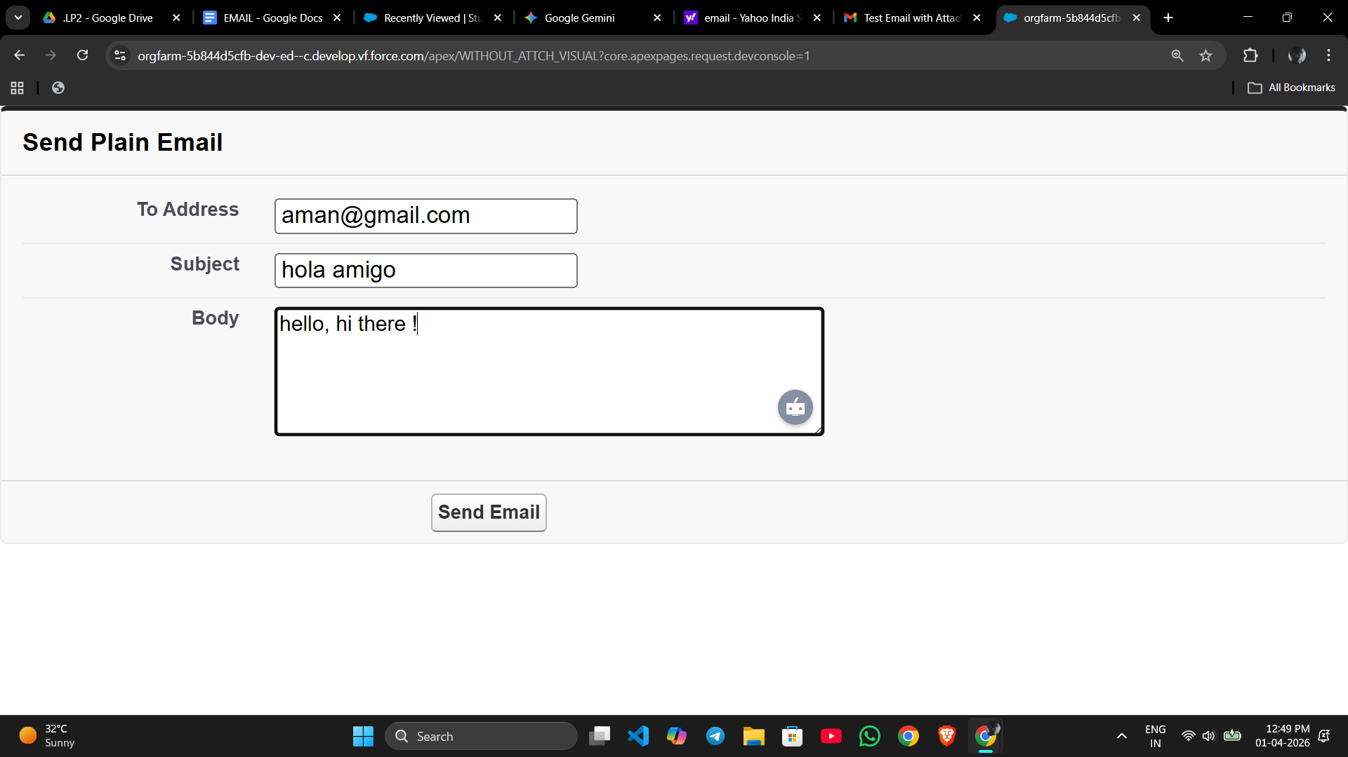

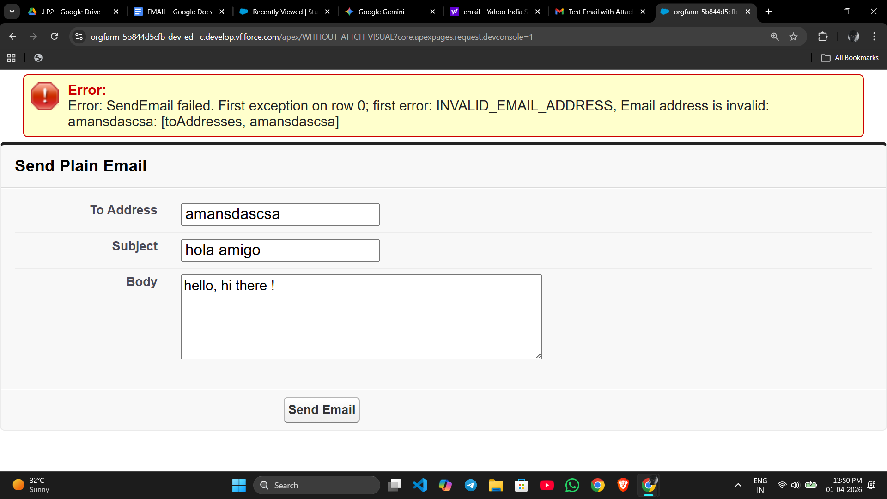

Now with attachment using visual force

Apex class
public class emailwithattach {
// Variables to hold data from the frontend
public String toAddress { get; set; }
public String emailSubject { get; set; }
public String emailBody { get; set; }

// Variables for the attachment
public transient Blob fileBody { get; set; }
public String fileName { get; set; }

public void sendEmail() {
try {
// Create the email object like in your assignment
Messaging.SingleEmailMessage mail = new Messaging.SingleEmailMessage();
mail.setToAddresses(new String[] { toAddress });
mail.setSubject(emailSubject);
mail.setPlainTextBody(emailBody);

// Logic to attach the file if one is uploaded
if (fileBody != null && String.isNotBlank(fileName)) {
Messaging.EmailFileAttachment efa = new Messaging.EmailFileAttachment();
efa.setFileName(fileName);
efa.setBody(fileBody);
mail.setFileAttachments(new Messaging.EmailFileAttachment[] { efa });
}

// Send the email
Messaging.SendEmailResult[] results = Messaging.sendEmail(new Messaging.SingleEmailMessage[] {mail});

if(results[0].isSuccess()){
// Show success message on the frontend
ApexPages.addMessage(new ApexPages.Message(ApexPages.Severity.CONFIRM, 'Email Sent Successfully'));
} else {
ApexPages.addMessage(new ApexPages.Message(ApexPages.Severity.ERROR, 'Email Failed: ' + results[0].getErrors()[0].getMessage()));
}
} catch (Exception e) {
ApexPages.addMessage(new ApexPages.Message(ApexPages.Severity.ERROR, 'Error: ' + e.getMessage()));
}
}
}

Visualforce page
<apex:page controller="emailwithattach">
<style>
.header-title {
font-size: 24px;
color: #005fb2;
margin-bottom: 15px;
}
</style>

<h2 class="header-title">Send Email with Attachment</h2>

<apex:pageMessages id="messages"/>

<apex:form >
<apex:pageBlock title="Compose Email">
<apex:pageBlockSection columns="1">

<apex:inputText value="{!toAddress}" label="Recipient Email" required="true"/>
<apex:inputText value="{!emailSubject}" label="Subject" required="true"/>
<apex:inputTextarea value="{!emailBody}" label="Message Body" rows="6" cols="60" required="true"/>

<apex:pageBlockSectionItem >
<apex:outputLabel value="Attachment" />
<apex:inputFile value="{!fileBody}" filename="{!fileName}" />
</apex:pageBlockSectionItem>

<apex:commandButton value="Send Email" action="{!sendEmail}" />

</apex:pageBlockSection>
</apex:pageBlock>
</apex:form>
</apex:page>

